**ASIA INVERTER(30 WATTS) CEILING FANS:**

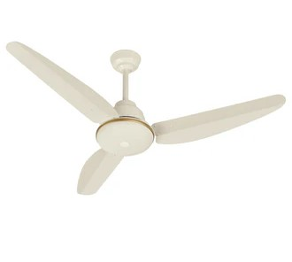

**Price: 16,595.00**

Asia Inverter (30 Watts) Fans are a game-changer in energy-efficient cooling solutions. These sleek and modern fans boast advanced inverter technology that optimizes airflow while minimizing power consumption, using only 30 watts of energy. With their whisper-quiet operation, variable speed control, and reversible functionality, Asia Inverter Fans provide unparalleled comfort and flexibility. Their durable construction and rust-resistant coating ensure a long-lasting and reliable performance, making them an excellent choice for residential and commercial spaces seeking to reduce their carbon footprint without compromising on cooling efficiency.

**Key features of asia inverter(30 watts) ceiling fans include:**

* **Energy-Efficient:** Low power consumption (30 watts) for reduced electricity bills.
* **Inverter Technology:** Provides silent operation and enhanced durability.
* **Multiple Speed Options:** Adjustable settings for customized airflow.
* **Durable Construction:** Built with high-quality materials for longevity.
* **Compact Design:** Ideal for small to medium-sized rooms.
* **Quiet Operation:** Ensures minimal noise while in use.
* **Eco-Friendly:** Environmentally friendly with lower energy usage.